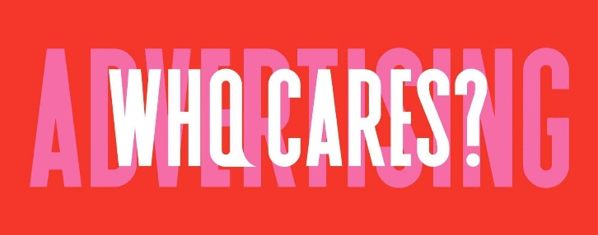

Advertising: Who Cares? What’s Next and Why
AWC was started because advertising is no longer doing what it is supposed to do:
- It is less effective at building brands, driving change and selling
- It is no longer providing enough funding to support a healthy media eco-system
There are solutions to these difficulties, if we tackle them openly. However, the business models that pervade the market prevent this from happening, so we need to address the root causes and their downstream effects.
The problems are multi-faceted and inter-connected, the nine AWC workstreams were designed to dive deep into them in search of answers. The results were presented at our Summit in mid-October and are available on the website and YouTube channel.
We started with the advertiser business model because true change can only occur if advertisers want it to. They have the greatest incentive and should be encouraged to reorganise in ways that make marketing work harder. This means being less siloed, and to push for more accurate measurement across multiple dimensions.
In parallel, agency business models should adapt to new market realities and the changing needs of advertisers.
Central to this is an approach by all market participants that creativity is an essential part of every aspect of marketing, not just the generation of messages. From creative department to creative business, as the workstream presenters put it.
Agencies should be advising advertisers of every shape and size how to advertise more effectively. They should do this without bias, being open across all disciplines. They should be accountable for results.
This openness should include the impartial recommendation of technologies that make advertising more effective and efficient.
Relationships and employment practices should be reworked to support a refreshed approach to the generation of effectiveness as a common cause.
In October 2024 we decided that AWC should play a key role as a central resource for the principles that underpin great advertising. The 2025 Summit created a range of materials to start to populate a suitable portal.
Our plan is to aggregate the best thinking, case studies, research and other relevant materials in one place online for anyone to access. These will come from the public domain.
It will be primarily aimed at advertisers, with contributions solicited from all appropriate sources. Eventually, we imagine much will be gathered and curated automatically.
The next stage is to build the resource and start to populate it with materials from the Summit and other sources. Some of the funding for this was generated by ticket sales to the Summit.
In the short-term, the Summit content plus ancillary materials provided by our workstreams either from the Summit or from activities since will be hosted on the www.advertisingwhocares.org site.
The portal will provide a basis for thought leadership, commentary, podcasts, interviews and other forms of guidance.
Some aspects may be analysed and pursued separately, with forums and discussions on specific topics.
‘Advertising: Who Cares?’ will continue to encourage open discussion about advertising in the interests of everyone involved in it, with the aim of making it better in every regard.
There seems little doubt that this is necessary.

